**FPT ACADEMY INTERNATIONAL**



## FPT – APTECH COMPUTER EDUCATION

BRIGHTWORLD

|  |  |  |  |
| --- | --- | --- | --- |
| **Center Name** | | FPT – Aptech – HCM2  Address: 590 Cach Mang Thang Tam, District 3, Ho Chi Minh City | |
| **Instructor** |  | Ms. Le Mong Thuy |  |
| **Class** |  | T1.2007.E1 |  |
| **Group** |  | 1 |  |
| **Group members** | | **Name** | **Student ID** |
|  |  | Lê Bá Duy | Student1270665 |
|  |  | Lê Quốc Anh Khoa | Student1271337 |
|  |  | Hồ Giang Nam | Student1271261 |
| **Duration** | Start date | 19th September 2020 |  |
| End date | 17th October 2020 |  |

**This is to certify that**

**Mr.:**

Le Ba Duy

Le Quoc Anh Khoa

Ho Giang Nam

**has successfully designed & developed**

eProject: BrightWorld website

**Submitted by:**

Le Ba Duy

**Date of issue:**

**Authorized Signature:**



**TABLE OF CONTENTS**

FPT – APTECH COMPUTER EDUCATION 1

ACKNOWLEGMENT 4

SYNOSIS 4

PROBLEM DEFINITION 4

CUSTOMER'S REQUIREMENTS SPECIFICATIONS (CRS) 5

Business/Project Objective: 5

Hardware/ Software Requirements: 6

SCOPE OF THE WORK (IN BRIEF) 7

Architecture and design of the system 8

Diagram of the website 9

TASK SHEET REVIEW 1 10

# ACKNOWLEGMENT

On behalf of all the members of group 1, I would like to thank you all for the hard works, supports to make this eProject complete successfully. Especially, Ms. Le Mong Thuy, our teacher, she helped us a lot from the day that we started to study at FPT Aptech. With this eProject, she has guided us with her enthusiasm and rigorous, because of her guiding, we would be able to finish this project. Besides, I want to thank all the team member of group 1, each of the team members has been working continuously in 4 weeks in order to complete this project. The last but not least, we would like to say thank you to our family for always supporting us, creating the best conditions for us to focus on the project, and putting faith in the dreams we pursue.

# SYNOSIS

We need to create a website that meets all the requirement of our customers, BrightWorld. They have a big collection about models and brands of LED lights as well. The main purpose of this website is to reach to the customers, who have interest in LED light.

# PROBLEM DEFINITION

The Web site is to be created based on the following requirements.

1. The Home Page should be created making use of Sections with a suitable logo, the header section can be added which will show images of various LED Lights.
2. The site must contain the links to navigate through various types of LED Lights.
3. Links of LED Lights can be categorized like (Bulbs, Spot Lights, Decoration Lights, Smart Lights etc.)
4. Specification and Pricing of Lights should be added along with the images.
5. Website should provide section for various brands offered in the store.
6. Gallery section should be added for viewing different images.
7. Feedback must be allowed to enter by the viewer
8. Site map, Gallery, about us, Queries link, Contact us link must be added. Address of the Company should be displayed using GeoLocation API (eg. GoogleMaps) and the email address which when clicked will invoke the local mail client from where they can send an email.
9. The complete description must be allowed to get download as pdf or doc file. The advertise section with various facilities provided should be mentioned.

# CUSTOMER'S REQUIREMENTS SPECIFICATIONS (CRS)

**Client: BRIGHTWORLD**

### Business/Project Objective:

BrightWorld is having store for LED Lights. They have collection of lights. Now with the changing environment, they want their presence on Internet. Hence they need to have a website with all their products listed on the website. Consumers should find it easy to view various products and decide upon purchasing the right product to meet their requirements.

A website needs to be designed to display various lights available with the store. Details of locations using GeoLocation API (eg. GoogleMaps), feedback must be included.

The website is to be developed for the Windows Platform using HTML5, JavaScript and Geolocation. The site should work well in all leading browsers including Chrome, IE, Firefox etc.

**Input to the system:**

* + - * Searching products based on brands, type of LED lights.

**Output from the system:**

* A menu that will categorize all the functions of the site.
* Display the list of available albums category wisely.
* Perform the search based on a particular: brands, type of LED lights.
* Site should be able to provide brief introduction/history about the showroom under About Us page.
* The location of the showroom under Contact-Us page.
* Besides the above requirements, the site should have look and feel as per the industry standards.

**Expected delivery date:** 17-October-2020.

**List of deliverables:**

* + - * Document Word.
      * User Guide.
      * Source code.

### 

### Hardware/ Software Requirements:

* **For developer**

**Hardware**

* + Intel Pentium 4 processor or higher
  + 1 Gigabytes of RAM or higher

**Software**

* + Windows 7 OS or higher
  + Adobe Dreamweaver
  + Web browsers such as IE, Chrome or Firefox are supporting HTML5, CSS3 and Javascript.
* **For web users**

**Hardware**

* + Intel Pentium 4 processor or higher
  + 512 Megabytes of RAM or higher

**Software**

* + Windows XP OS or higher
  + Web browsers such as IE, Chrome or Firefox are supporting HTML5, CSS3 and Javascript.

# SCOPE OF THE WORK (IN BRIEF)

After a long and detailed discussion, our group has decided to create a website contain the following webpages:

1. ***Homepage***: Display information about newest-selling products, an introduction about BrightWorld.
2. ***Brands***: Display all models of brands based on category (Bulbs, Spot Lights, Decoration Lights, Smart Lights etc.).
3. ***Type of LED Lights***: Give information about ‘RANG DONG’, ‘DIEN QUANG’, ‘PHILLIP’ etc.
4. ***About Us***: Display the information of the company and about us.
5. ***Contact***: Display the address of the company, allow customers to request any information they want from BrightWorld.

# Architecture and design of the system

Webpage request



Requested Page

**RENDERING**

**ENGINE**

**CSS CODE**

**HTML CODE**

**WEB SERVER**

**WEB BROWSER**

**CLIENT**

**SERVER**

# Diagram of the website

.

HOME

PRODUCT

CONTACT US

ABOUT US



# TASK SHEET REVIEW 1

|  |  |  |  |  |  |  |  |
| --- | --- | --- | --- | --- | --- | --- | --- |
| **Project Ref. No.:**  **eP/Advertisement Portal Management**  **System/01** | | **Project Title:** | **Activity Plan Prepared By:** | **Date of Preparation of Activity Plan:** | | | |
| **Sr.**  **No.** | **Task** | **Actual**  **Start Date** | **Actual Days** | **Team**  **Mate Names** | **Status** |
| 1 | Problem Statement | BrightWorld | Duy | 19-Sep-20 | 1 | Khoa | Completed |
| 2 | Analysis of BrightWorld requirements about the website | 19-Sep-20 | 1 | Khoa | Completed |
| 3 | The scope of the work (in brief) | 19-Sep-20 | 1 | Duy | Completed |
| 4 | Architecture and design of the system | 19-Sep-20 | 1 | Duy | Completed |
| 5 | Diagram of the website | 19-Sep-20 | 1 | Nam | Completed |
| 6 | Task Sheet | 19-Sep-20 | 1 | Nam | Completed |

|  |  |
| --- | --- |
| **Date:** | |
| Signature of Instructor:  **Ms. Le Mong Thuy** | Signature of Team Leader:  **Le Ba Duy** |

# SITE MAP

PRODUCT PAGE

PRODUCT

CONTACT US PAGE

CONTACT US

ABOUT US PAGE

ABOUT US

HOME PAGE

# MOCK OF THE WEBSITE

1. **Homepage**

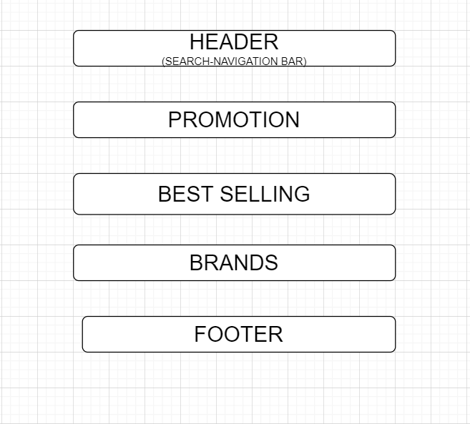

1. **ABOUT US**

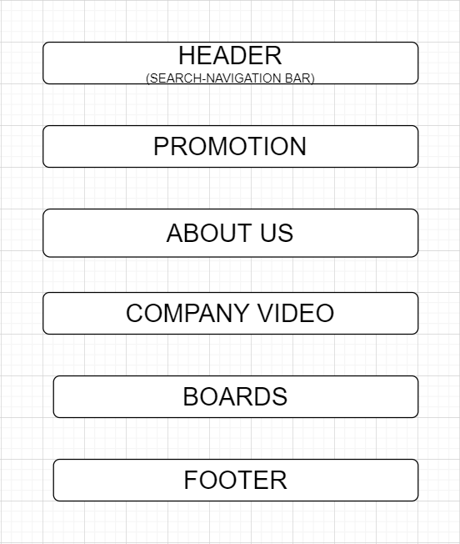

1. **CONTACT US**

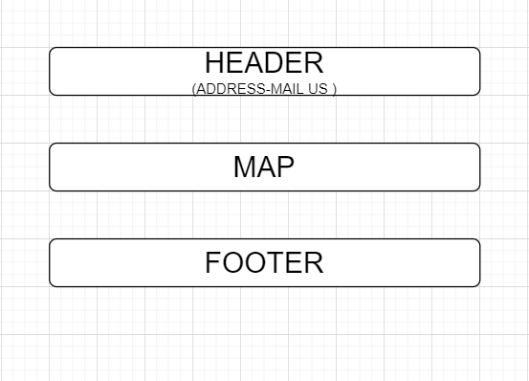

1. **PRODUCTS**

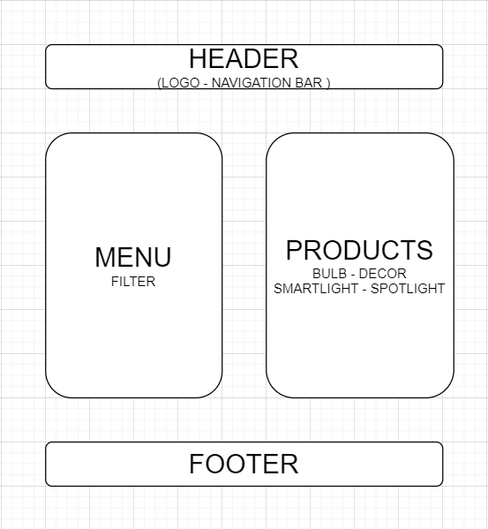

# 

# TASK SHEET REVIEW 2

|  |  |  |  |  |  |  |  |
| --- | --- | --- | --- | --- | --- | --- | --- |
| **Project Ref. No.:**  **eP/Advertisement**  **Portal Management System/01** | | **Project Title:** | **Activity Plan Prepared By:** | **Date of Preparation of Activity Plan:** | | | |
| **Sr.**  **No.** | **Task** | **Actual Start Date** | **Actual Days** | **Team Mate Names** | **Status** |
| 1 | Site map | Brightworld | Khoa | 10-Oct-20 | 1 | Duy | Completed |
| 2 | Mock of the website | 10-Oct-20 | 2 | Khoa | Completed |
| 3 | Task sheet | 10-Oct-20 | 2 | Nam | Completed |

|  |  |
| --- | --- |
| **Date:** | |
| Signature of Instructor:  **Ms. Le Mong Thuy** | Signature of Team Leader:  **Mr. Le Ba Duy** |

# WEBSITE DESCRIPTION

1. **Home Page**

* Description

Home page displays following information:

* Feature promotion product of company.
* Best selling.
* Brands.
* Screenshot

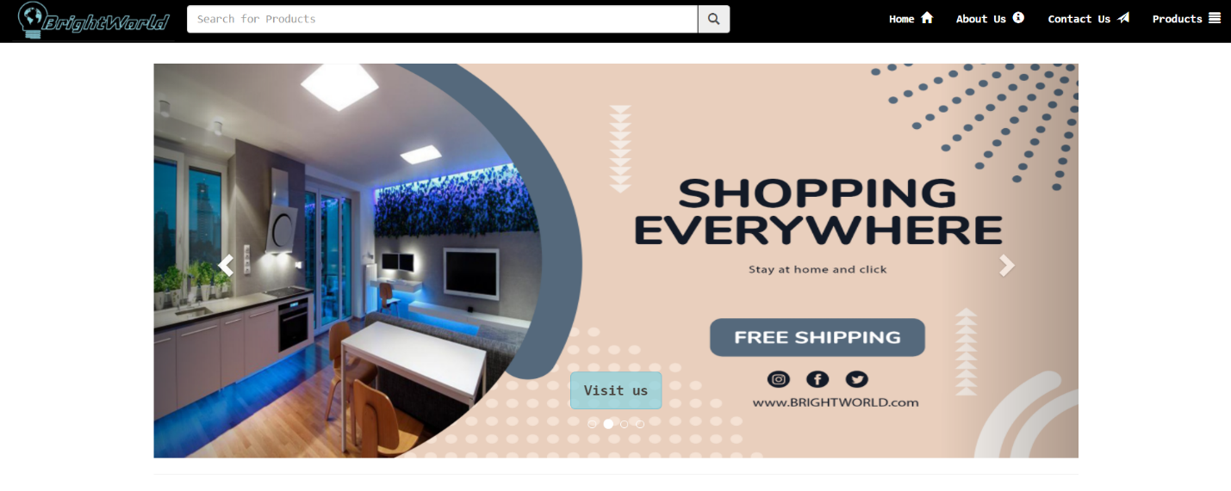

Best selling and brands

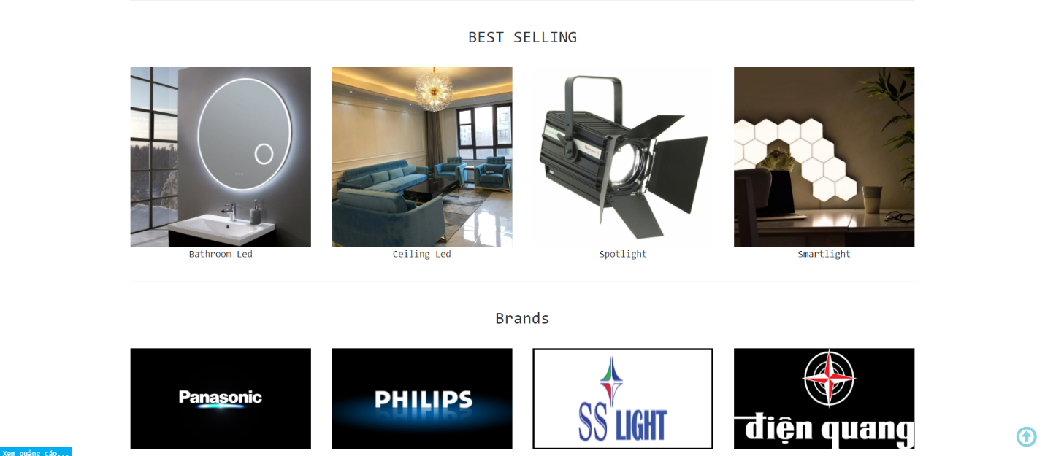

1. **About us**

* Description

This page displays information about the history of Brightworld, our video that we provide and our team member.

* Screen shot

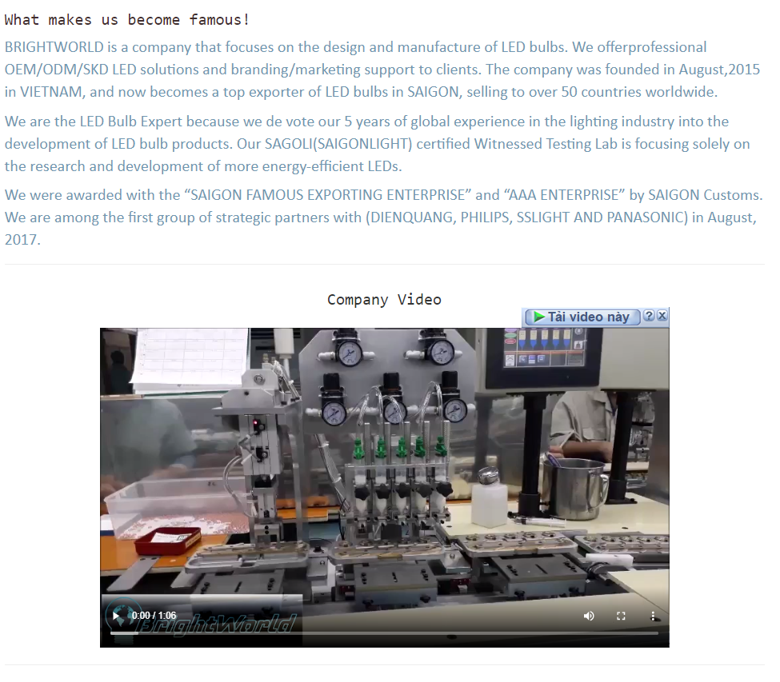



1. **Contact us:**

* Description

This page displays contact information: location, telephone number, email and a quick contact form for customer.

* Screen shot

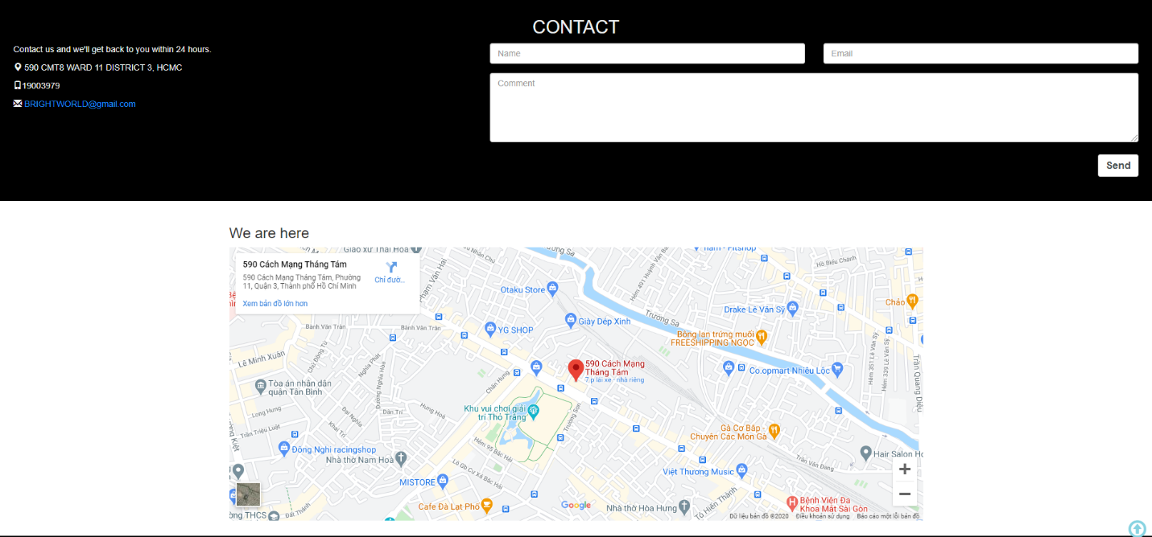

1. **Product:**

* Description:

This page displays following information:

* All product that being sold at Brightworld (bulb, decoration, smartlight, spotlight), when click on 1 specific item, it will show the detail of that item
* Menu filter and search window to easily find items based on categories.
* Screen shot

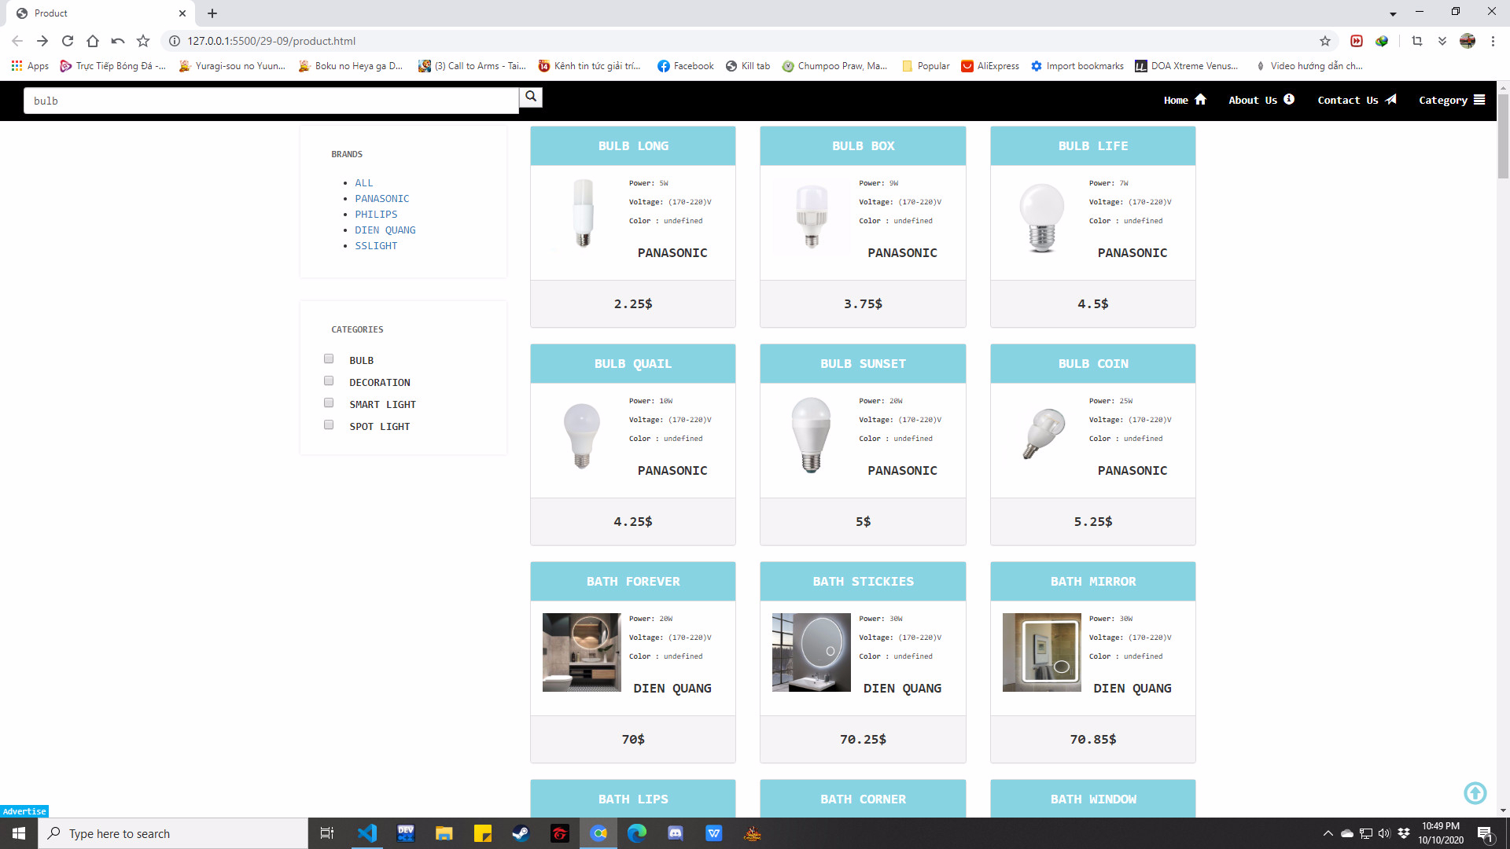

Detail product:

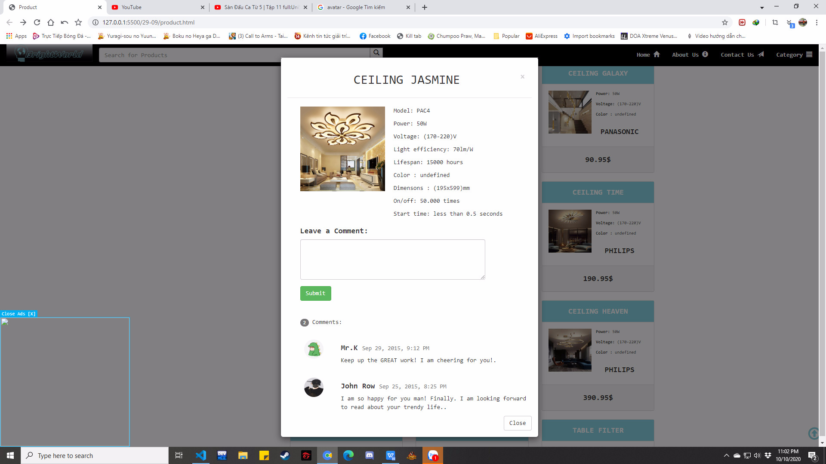

**JAVASCRIPT DESCRIPTION**

* + - 1. **Navigation (Product page) - search bar:**
* Description:

**This script is used for searching product through keyword and filtering product by brands**

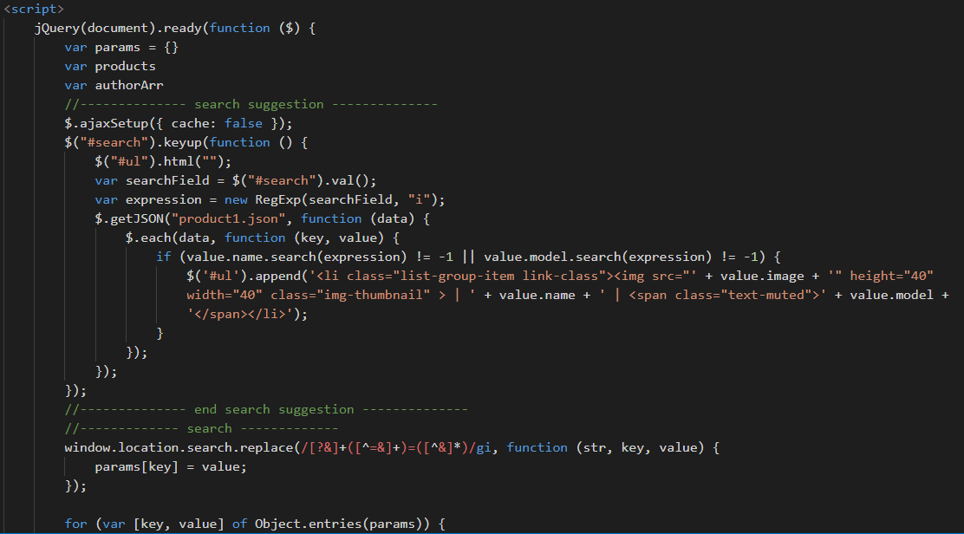

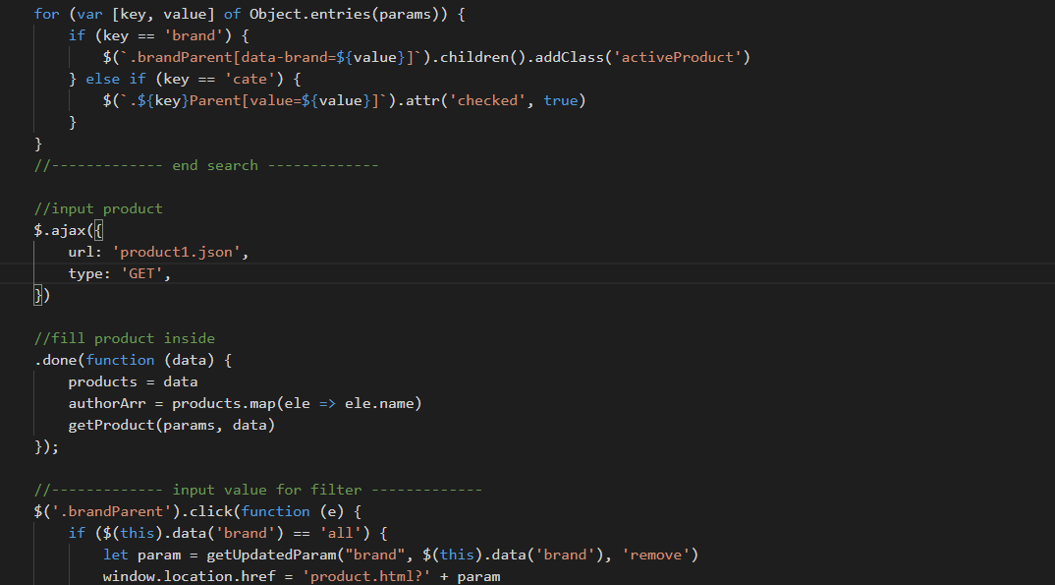

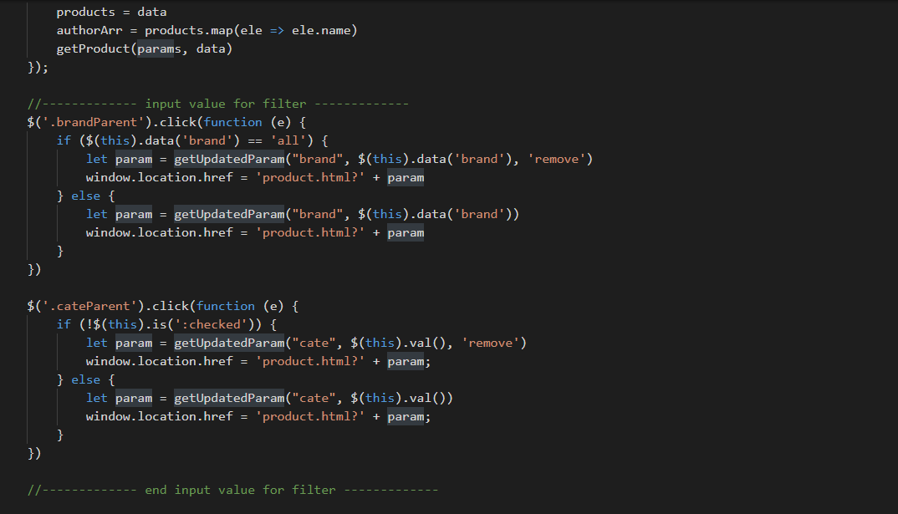

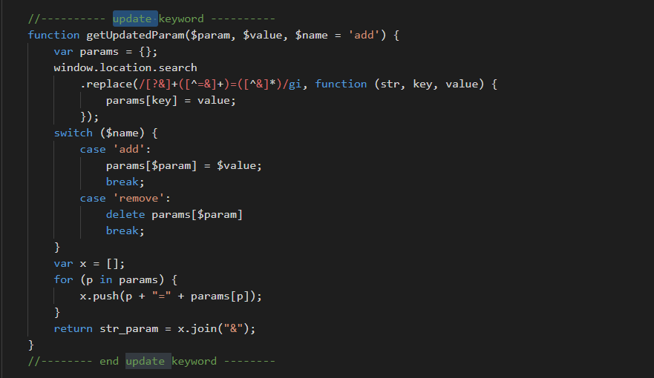

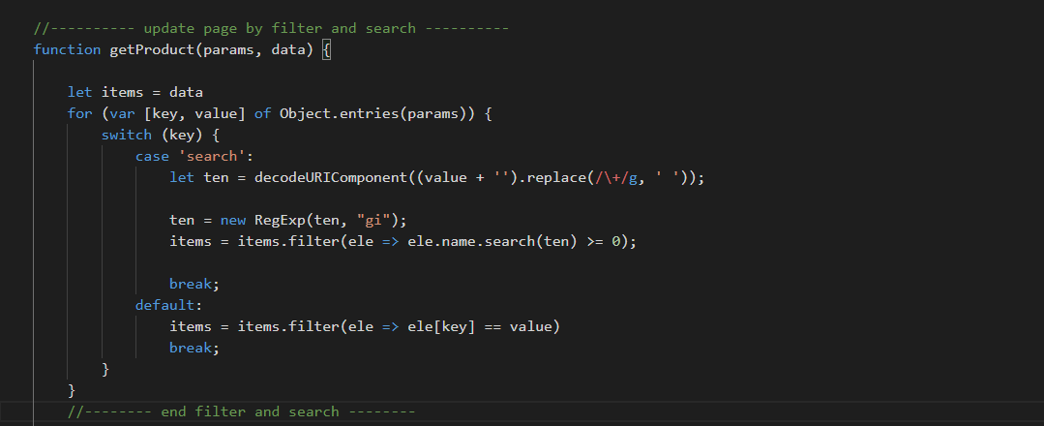

**This script is used for showing together with updating all products bases on search and filter functions:**

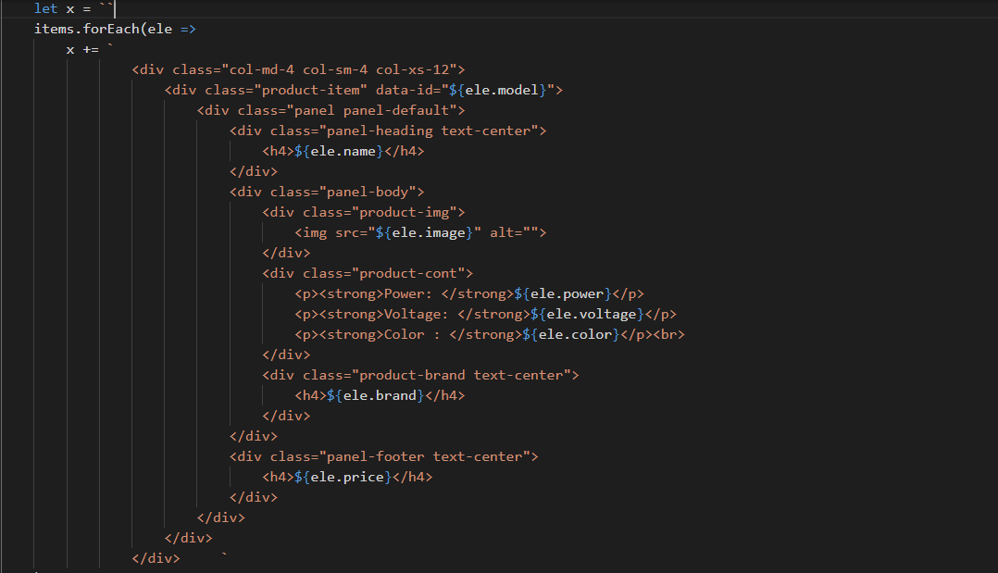

**This script is used for showing product details in modal popup:**

Click on:

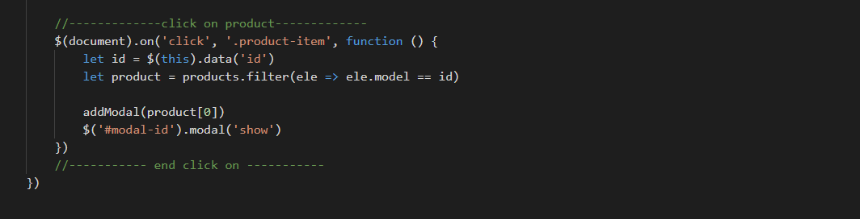

Showing products in details1:

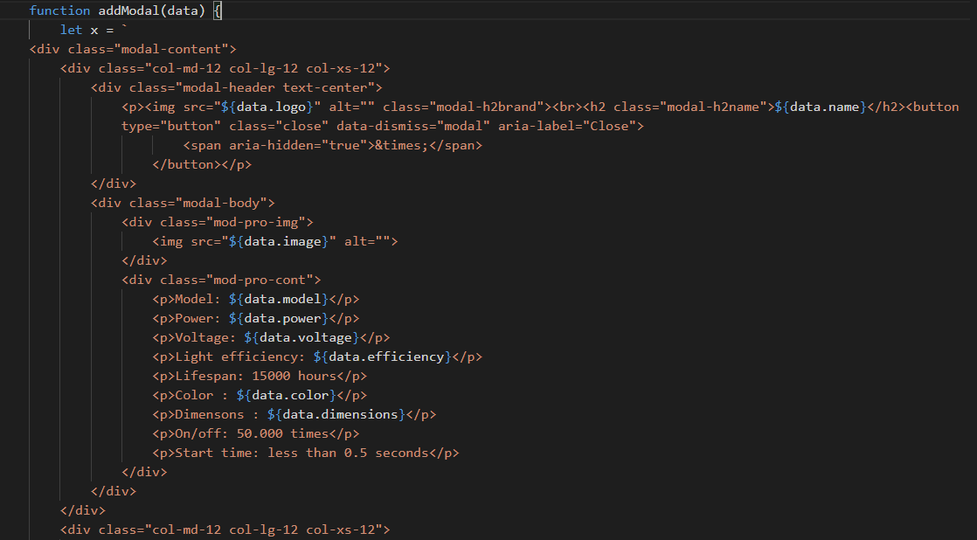

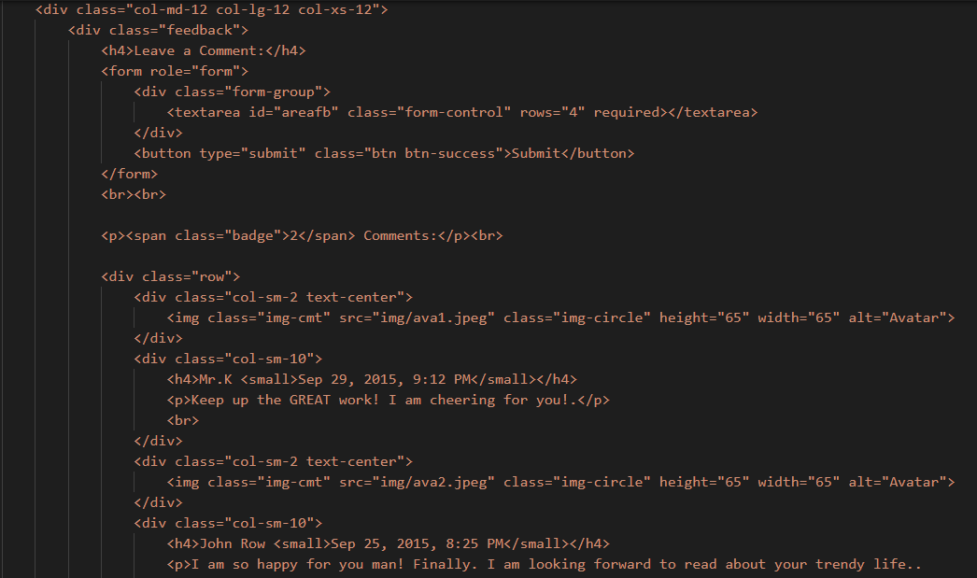

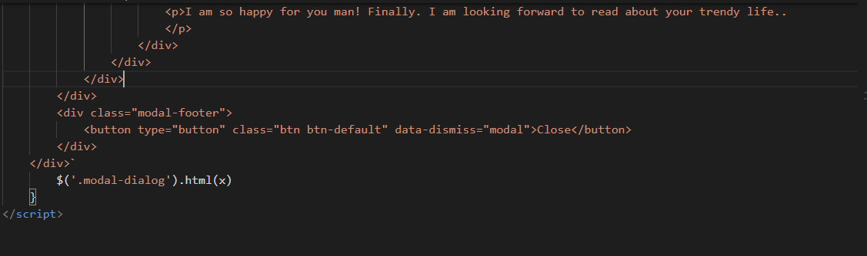

**This scripts is used to program the return top button, the feedback button and showing ads popup.**

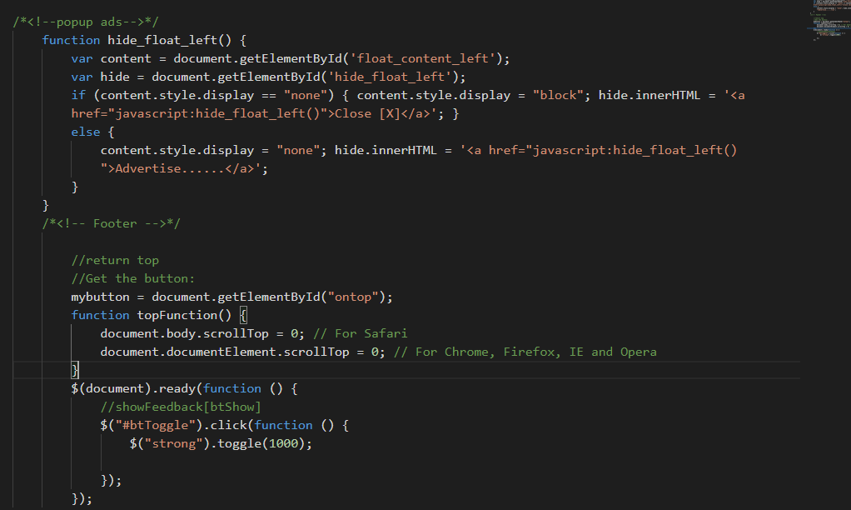

# TASK SHEET REVIEW 3

|  |  |  |  |  |  |  |  |
| --- | --- | --- | --- | --- | --- | --- | --- |
| ***Project Ref. No.:***  ***eP/Advertisement Portal Management System/01*** | | ***Project Title:*** | ***Activity Plan Prepared By:*** | ***Date of Preparation of Activity Plan:*** | | | |
| ***Sr.***  ***No.*** | ***Task*** | ***Actual Start***  ***Date*** | ***Actual Days*** | ***Team Mate***  ***Names*** | ***Status*** |
| *1* | *Home page (navigation bar)* | ***BrightWorld*** | ***Duy*** | 19-Sep-20 | *1* | *Nam* | *Completed* |
| *2* | *Contact Us* | 23-Sep-20 | *2* | *Khoa* | *Completed* |
| *3* | *About us* | 23-Sep-20 | *1* | *Khoa* | *Completed* |
| *4* | *Product* | 27-Sep-20 | *1* | *Khoa* | *Completed* |
| *5* | *Feedback* | 27-Sep-20 | *1* | *Khoa* | *Completed* |
| *6* | *Sitemap* | 29-Sep-20 | *1* | *Khoa* | *Completed* |
| *7* | *Javascript for modal, search & filter* |  |  | 29-Sep-20 | *1* | *Duy* | *Completed* |
| *8* | *Javascript for footer* |  |  | 03-Oct-20 | *1* | *Khoa* | *Completed* |
| *9* | *Javascript for ads, return top button* |  |  | 15-Oct-20 | *1* | *Nam* | *Completed* |

|  |  |
| --- | --- |
| **Date: 15/10/2020** | |
| Signature of Instructor:  **Ms. Le Mong Thuy** | Signature of Team Leader:  **Mr. Le Ba Duy** |